Hospital Manger Web App

By

Lovepreet

_________

Level-6

Final Project

Table of Contents

Project Proposal 3

Goals and Objectives 3

Project Scope 3

Project Specifications 3

Target Audience 3

Project Deliverables 4

Resource Requirements 4

Project Tasks and Milestones 4

Project Assumptions 5

Project Report 5

Detail Design 6

Login Page 6

Register Page 6

Clerk Home Page 7

Doctor Home Page 7

All Doctor Schedule Clerk Page 8

All Department Clerk Page 8

Appointment Booking Patient Page 9

All Appointment Patient Page 9

Project Testing 10

User Manual 10

Summary 10

System Configuration 10

User Access Levels 10

**Client Detail**

|  |  |
| --- | --- |
| Client Name | Manjinder Singh |
| Company | Hospital manager web app |
| Email | Manjindersingh1234@gmail.com |

# 

# Project Proposal

## Goals and Objectives

In today scenario, there is concept of ease of everything, and this ease must be available in accessing appointment of doctor at Hospital.

To make this feasible, Hospital Manager Web App is a step towards this goal.

This is a web portal, where different authorise, user can access it in efficient manner. So, that the task of hospital doctor appointment goes smooth.

And due to nature of web portal, it can be accessible on internet and patient takes advantage from this web application.

In Hospital Manager Web Application, There are mainly three kind of user with different authority.

1. Clerk
2. Doctor
3. Patient

## Project Scope

The scope of this project is to implement an app named “Hospital Manager”, with the help of this web application, it provide a easy accessible mechanism to schedule Patient doctor appointment. The duration of the project is 20 working days which is equals to 4 weeks.

## Project Specifications

* Clerk, Doctor and Patient login/logout
* Clerk has more authority because he/she is responsible to maintain all department, doctor and their schedule details by performing CRUD operation on database.
* Clerk can register new clerk as well as doctors in system.
* New Patient can easily register on web portal.
* Registered Patient can view all doctor schedule as well as they are capable to schedule their appointment on desire date.
* Registered Patient is capable to view his previous or upcoming booking appointment.
* Registered Doctor can view his/her appointment schedule.

## Target Audience

The target audience for this project is the hospital staff as well as their patients. The age can go from 18 plus to 100 plus.

## Project Deliverables

The deliverables of the project are:

|  |  |
| --- | --- |
| Deliverable | Description |
| Final Report | This will be the final report of the project. |
| Coding | The executable code of the project will go under this. |
| Documentation | This portrays the documentation of the project. |
| Testing | All the test details will be covered in this part. |

## Resource Requirements

* Windows Operating System.
* Microsoft word for documentation.
* Asp.net MVC Framework
* 64-bit Processor and 4 GB or more RAM
* Identity framework- ASP

## Project Tasks and Milestones

|  |  |  |  |  |
| --- | --- | --- | --- | --- |
| **Tasks** | **Week-1** | **Week-2** | **Week-3** | **Week-4** |
| Brainstorming and analysis |  |  |  |  |
| Planning and initial meeting Project Proposal document. |  |  |  |  |
| Database Design and UI Design |  |  |  |  |
| Identity framework implementation |  |  |  |  |
| Coding for admin and reporter |  |  |  |  |
| Testing |  |  |  |  |
| Final Documentation and closing |  |  |  |  |

## Project Assumptions

Following are the assumption made while implementing the project:

* One Clerk, 8 registered doctor and one registered patient will be registered by default.
* Application will be free and open source.

# Project Report

#### Functional and Non-Functional

|  |  |
| --- | --- |
| Users | Functional |
| Clerk | * Login/logout * Register new clerk as well as new doctor in system * Clerk has more authority like to maintain all details of Department, doctor, doctor schedules and capable to view all booking registered online. |
| Doctor | * Login/Logout * Doctor capable to view his/her patient appointment * Login using valid credentials |
| Patient | * Login/Logout * Registered Patient capable to book their appointment with available doctor * Registered Patient can view all his/her previous or future appointment done by himself/herself * Login using valid credentials |
|  | Non- Functional |
|  | * High speed * Fast Loading time * High performance and security * All browsers compatibility. |

## Detail Design

### Login Page

The main landing page our Hospital Manager Portal app from different type of user can access it.

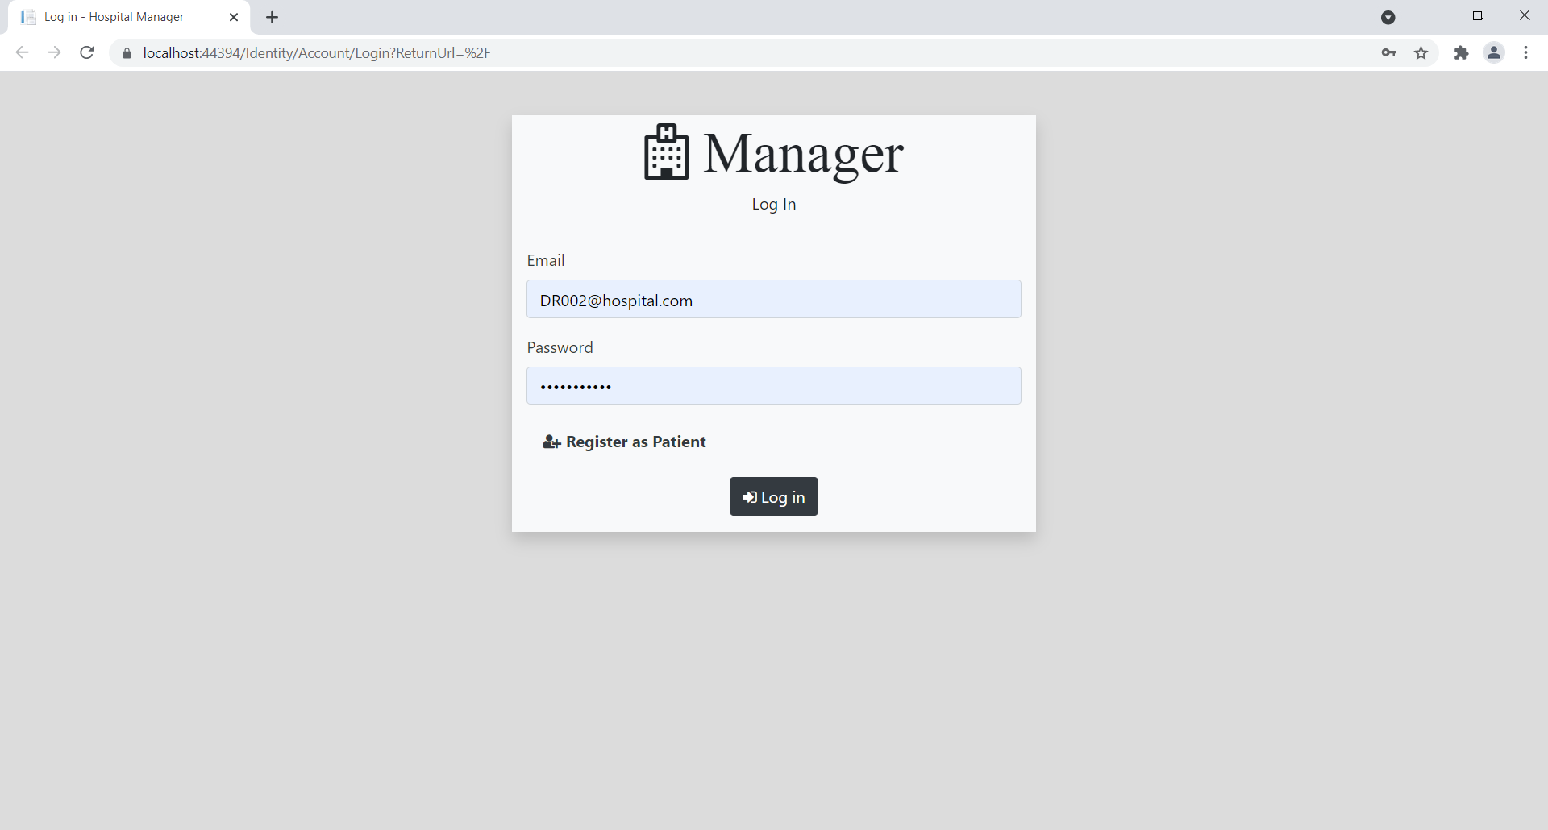

### Patient Register Page

With this page, Patient can register them self.

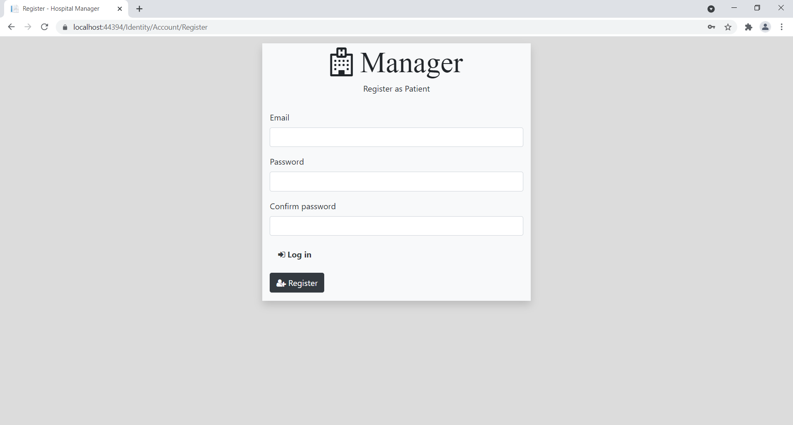

### Clerk Home Page

If user is successfully authenticated as a clerk authority, then, this home page will appears.

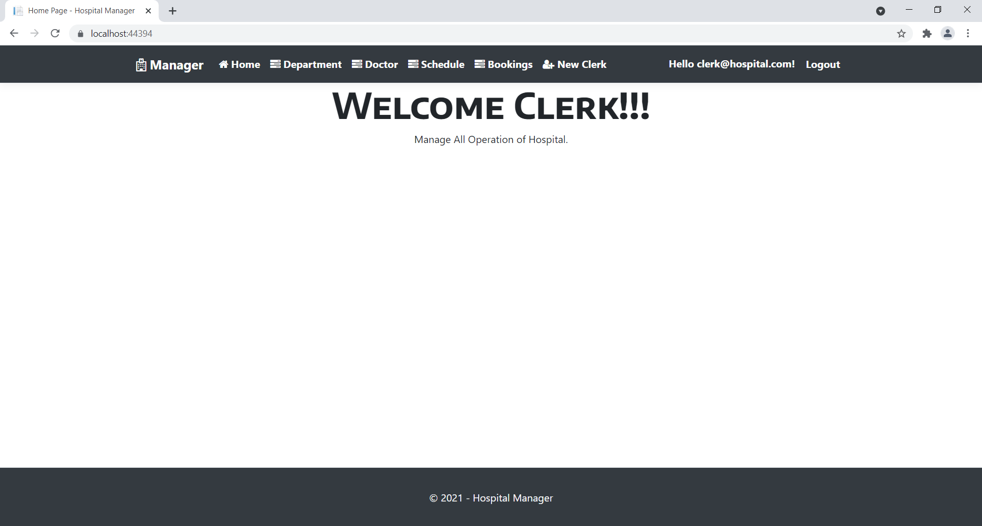

Doctor Home Page

If user is successfully authenticated as a doctor authority, then, this home page will appears   
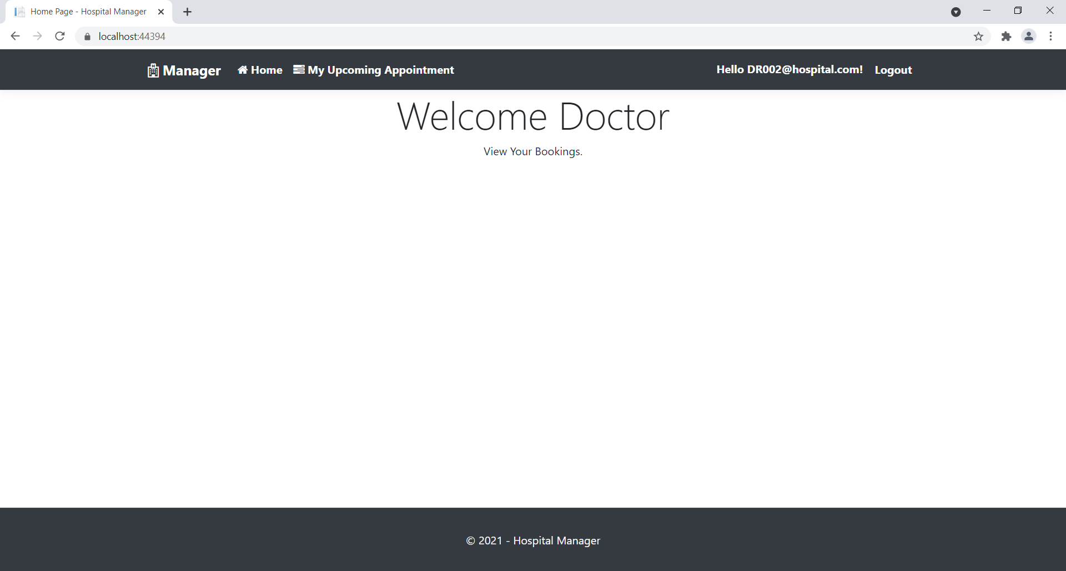

### All Doctor Schedule Cleark Page

With the help of this page clerk can view all doctor schedule as well as authority to manage them.

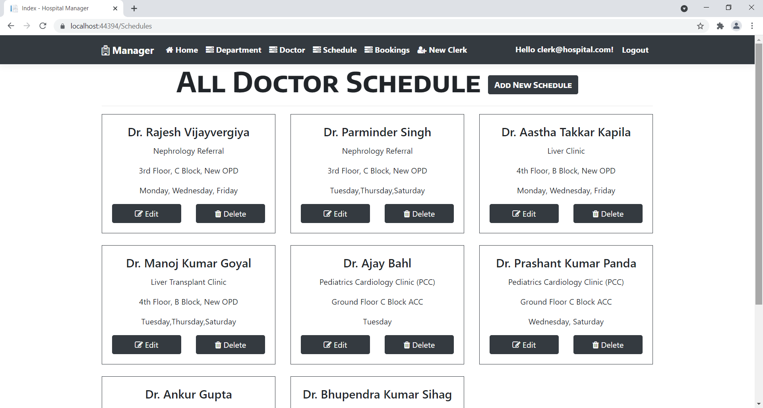

All Department Clerk Page

With the help of this page, clerk can manage all department of a hospital.

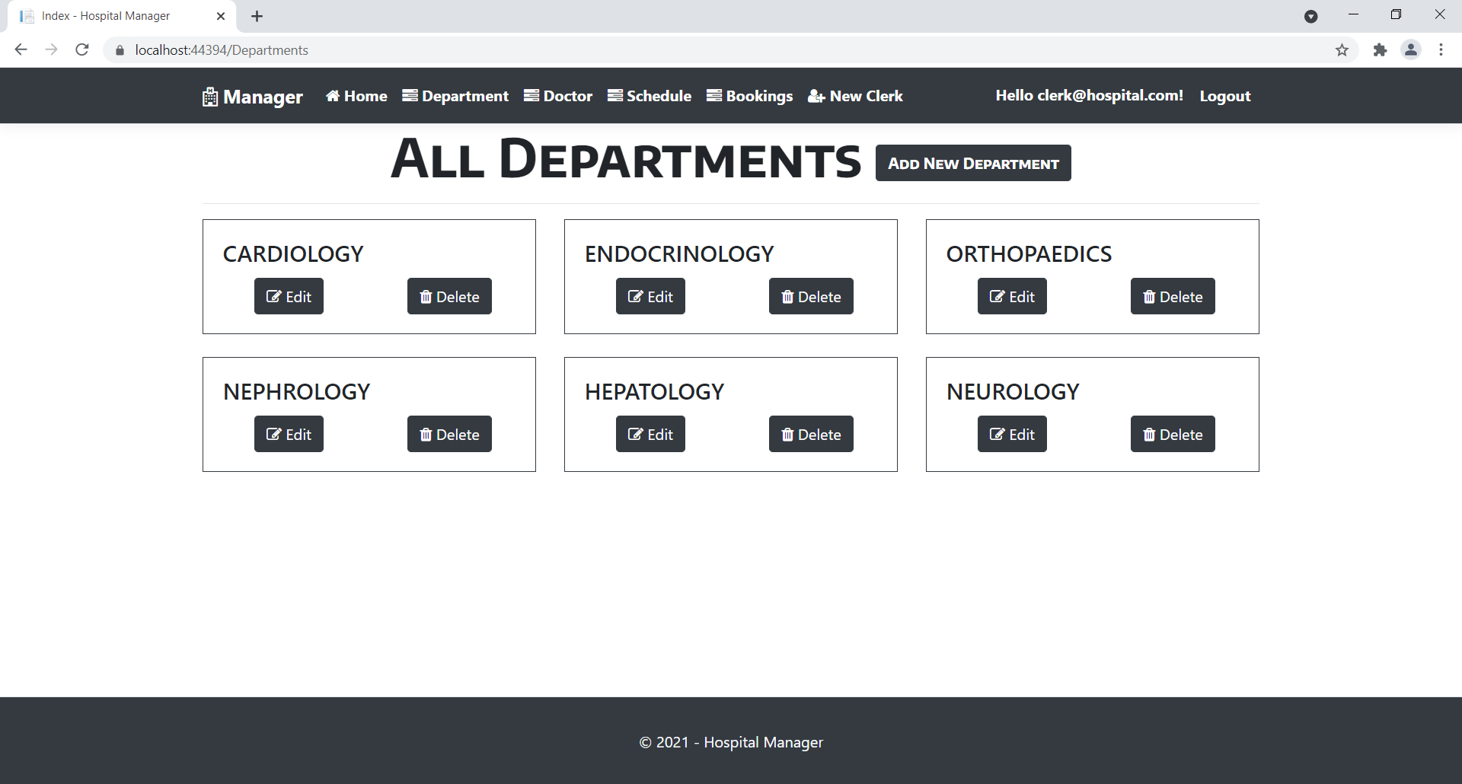

Appointment Booking Patient Page

In this page, a registered patient is capable to schedule his/her appointment of future.

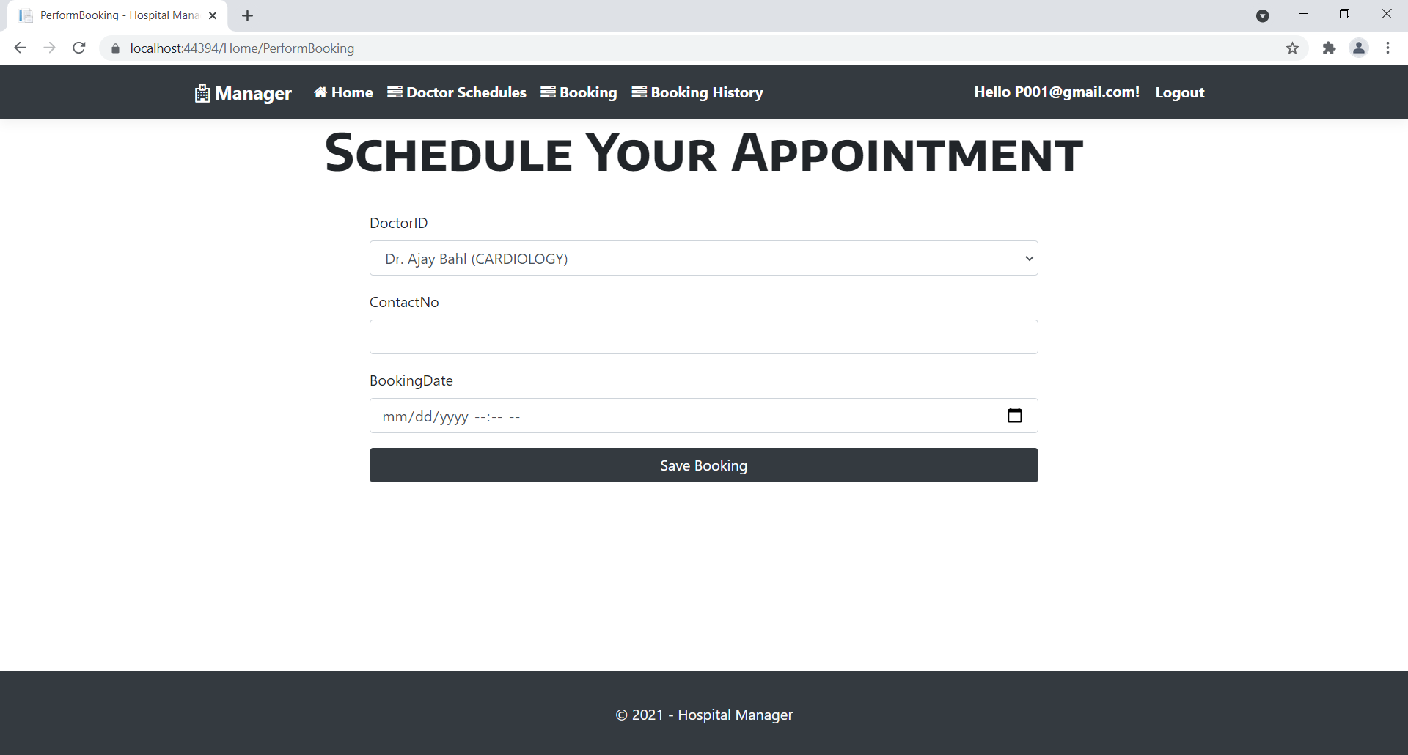

All Appointment Patient Page

In this page, registered patient can access all his/her upcoming appointments.

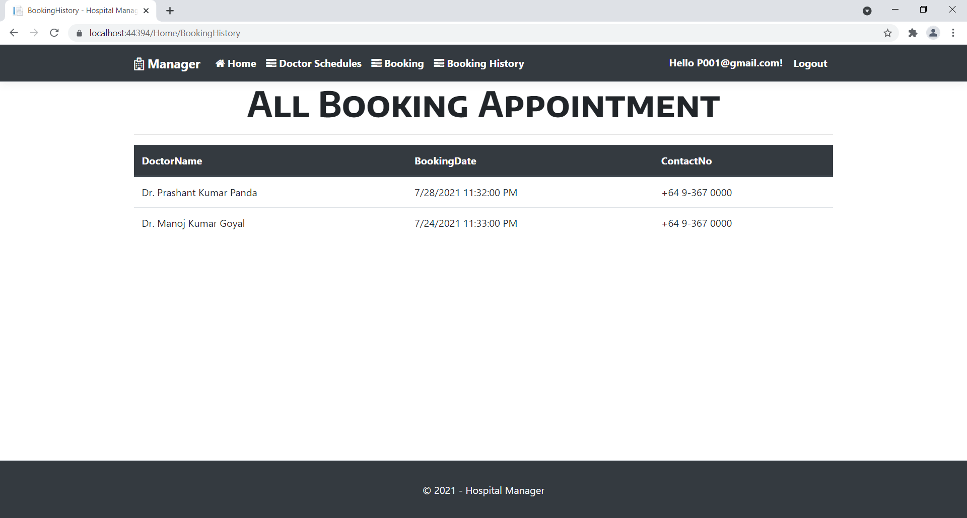

## 

## Project Testing

The testing file for usability testing is attached as [usability test.xlsx](usability%20test.xlsx)

# User Manual

The main purpose of the application Hospital Manager to provide a portal to smooth the process of handing hospital operation. Now, this app capable to manage doctor appointment booking process. For achieving this there are different type of registered user with different role like Clerk, Doctor and Patient.

## Summary

### System Configuration

This app will be useful to for distributing mobile information in presentable format.

### User Access Levels

Only registered users can access the features of this application.

* **Clerk:** Clerk has full access of the app can register new Clerk as well as Doctor registered in hospital system
* **Doctor:** Doctor has limited access.
* **Registered Patient:** New patient can register and existing can login using their own credentials. They have limited access.